✴

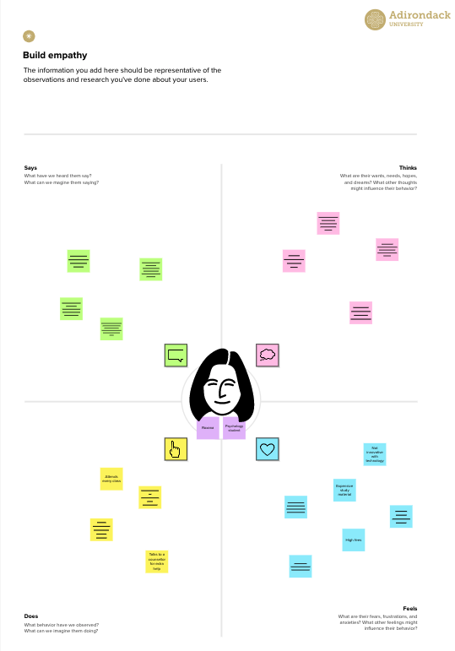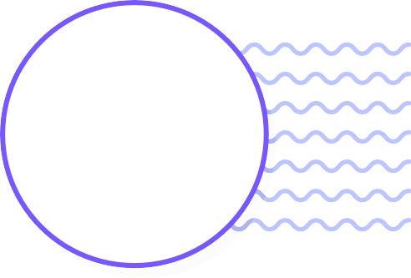

**Build empathy**

The information you add here should be representative of the observations and research you've done about your users.

Empathy map

Use this framework to develop a deep, shared understanding and empathy for other people. An empathy map helps describe the aspects of a user's experience, needs and pain points, to quickly understand your users’ experience and mindset.

An existing standards gas installation no greater than 30litres.

Many pipelines transport petroleum products and natural gas

Lack of in proper appliances and improper malfunctions.

# Says

What have we heard them say? What can we magine them saying?

# Thinks

What are their wants, needs, hopes, and dreams? What other thoughts might influence their behavior?

Store gas cylinders as per regulations

Check whether gas cylinders maintained properly

Aim identify where the leakage takes place.

Images will store all images and resources

Says Think

Gas Leakage Monitoring

System

By the exact maintenance prevent gas leakage

Does

Feels

Natural gas is relatively safe, efficient

Preventing gas leakage helps to prevents accidents

Turn of all naked flames and eliminates all source of ignition

If it’s not maintained properly accidents takes place

Leakage of gases associated with industrial operations

[**Share template feedback**](https://muralco.typeform.com/to/CiqaHVat?typeform-source=app.mural.co)

# Does

What behavior have we observed? What can we imagine them doing?

# Feels

What are their fears, frustrations, and anxieties? What other feelings might

influence their behavior?

**Template**

**Need some inspiration?**

See a finished version of this template to kickstart your work.

[**Open example**](https://app.mural.co/template/f44b7843-7c23-408c-bd36-7b0c9409dc20/96efd10c-81d2-401e-8072-4e87935e5d6b)